***Resume of Md.Hazrat Ali***

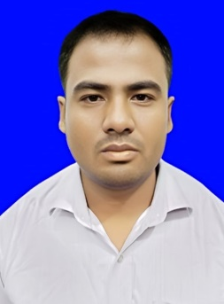**Md. Hazrat Ali**  
West Khutamara, Khutamara-5330,   
Jaldhka,Nilphamari

Email: mdhazratali58585@gmail.com  
Phone:01773778783

LinkedIn: in/md-hazrat-ali-a004bb2b6

Github: https://github.com/mdhazrat5858

**Education**

**Bachelors of social science Examination(**B.S.S.**)**

Institution :Nilphamari Govt Collage

Board :National university

Group :Political science

CGPA :2.84 (out of 4.00scales)

**Higher secondary Certificate Examination(HSC)**

Institution : Khutamara Alim Madrasah

Board : Madrasah

Group : Humanities

GPA : 3.86(out of 5.00 scales)

**Secondary school Certificate Examination**

Institution : Khutamara Alim Madrasah

Board : Madrasah

Group : Humanities

GPA : 4.44(out of 5.00 scales)

**Skills**

* **Fundamentals of Computers**: Proficient in using Microsoft Office Suite (Word, Excel, PowerPoint)
* **Operating Systems**: Knowledge of Windows, Mac OS, and basic Linux
* **Data Entry and Management**: Experience in data entry and organizing information for analysis
* **Research**: Skilled in qualitative and quantitative research methods
* **Political Analysis**: Strong understanding of political systems, theories, and methodologies
* **Communication**: Excellent written and verbal communication skills
* **Teamwork and Leadership**: Proven ability to collaborate in team settings and take initiative when needed

**Certifications**

* **Computer Fundamentals and office Application Training**

**Training**

**EDGE Computer Basic Training**

* MS Word
* MS Excel
* MS PowerPoint
* MS Access

**Languages**

* **English**
* **Bangla**

**Personal Information:**

1. Name :Md. Hazrat Ali

2. Father’s Name : Md. Baharul Islam

3. Mother's Name :Anowara

4. Present Address : Vill: West Khutamara, P.O: Khutamara,

P.S- Jaldhaka, Dist: Nilphamari.

5. Permanent Address: Vill: West Khutamara, P.O: Khutamara,

P.S- Jaldhaka, Dist: Nilphamari.

6. Date of Birth : 20/09/1999

7. Nationality : Bangladeshi (by Birth)

8. Religion : Islam.

9. Marital Status : Unmarried

10. Sex : Male

11. Mobile No : 01773778783

12. National Id : 1504441401

**References**

**Reference:01**

Name :Md Yousuf Ali

Organization : Nilphamari Govt Collage

Deasignation : Lecturer of ICT

**Reference:02**

Name :Md. Jahangir Alam

Organization : Nilphamari Govt Collage

Deasignation : Associate Professor of Chemistry



**Signature**

**Date:**